Mobile Simulator and Control Panel User Guide

Version: 1.0.1
DocCode: SW-BASE-UG-0040
Date: April 13, 2010


www.spreadtrum.com
Important Notice
Copyright Notice
Copyright © 2010, Spreadtrum Communications, Inc. All rights reserved.
Trademarks
Spreadtrum Communications, Inc. and Spreadtrum Communications, Inc.'s products are exclusively owned by Spreadtrum Communications, Inc. References to other companies and their products use trademarks owned by the respective companies and are for reference purpose only.
Warranty Disclaimer
Spreadtrum Communications, Inc. makes no representations or warranties, either expressed or implied, by or with respect to anything in this document, and shall not be liable for any implied warranties of merchantability or fitness for a particular purpose or for any indirect, special or consequential damages.
Confidentiality
The information contained herein (including any attachments) is confidential. The recipient hereby acknowledges the confidentiality of this document, and except for specific purposes, this document shall not be disclosed to any third party.
About This Document

Purpose
The Mobile Simulator Control Panel User Guide describes how to use the control panel for the mobile simulator.

Intended Audience
This document is intended for:
- R&D engineer

Organization
This document consists of three chapters and is organized as follows.
Chapter | Describes
1 Introduction | The functions and operating environment of the control panel for the mobile simulator(MSDev).
2 Notes for Use | How to use the control panel for the mobile simulator.
3 Notes for Development | All the APIs involved in the development of the mobile simulator control panel.

Contents
1 Introduction 1-1
1.1 Overview 1-1
1.2 System Requirements 1-1
1.3 Files 1-1
1.3.1 Files for Running 1-1
1.3.2 Files for Development 1-1
2 Notes for Use MSDev 2-2
2.1 Mobile Simulator 2-2
3 Notes for Use Control Panel 3-5
3.1 Control Panel 3-5
3.2 System Information 3-7
3.2.1 Glossary 3-8
3.2.2 Element Description 3-9
3.2.3 How to Use 3-10
3.3 Initiating and Receiving Calls 3-11
3.3.1 Element Description 3-11
3.3.2 How to Use 3-12
3.4 Sending and Receiving a Short Message 3-13
3.4.1 Element Description 3-14
3.4.2 How to Use 3-14
3.5 Cell Broadcast 3-15
3.5.1 Element Description 3-15
3.5.2 How to Use 3-16
3.6 Setting Supplementary Services 3-17
3.6.1 Glossary 3-18
3.6.2 Element Description 3-20
3.6.3 How to Use 3-21
3.7 Displaying the Message Exchange Between the MMI and the PS 3-21
3.7.1 Element Description 3-21
3.7.2 How to Use 3-22
3.8 Using the Analog File System 3-22
3.8.1 Glossary 3-23
3.8.2 Element Description 3-23
3.8.3 How to Use 3-24
4 Notes for Development 4-26
4.1 Required Files for Development 4-26
4.2 APIs 4-27
4.2.1 Functions Declared in ConPanFunc.h 4-27
4.2.2 Functions Stated in ConPan.h 4-31
4.3 Integrating Control Panel Functions into MSDev 4-33

Figures
Figure 2-1 Control Panel 2-2
Figure 2-2 System Info tab page 2-4
Figure 2-3 Setting SIM card information 2-6
Figure 2-4 Call Control tab page 2-7
Figure 2-5 SMS Control tab page 2-9
Figure 2-6 Cell Broadcast tab page 2-11
Figure 2-7 SS Control tab page 2-14
Figure 2-8 Message Flow tab page 2-17
Figure 2-9 File System tab page 2-19

Tables
Table 2-1 Labeled elements on the control panel 2-3
Table 2-2 Labeled elements on the System Info tab page 2-4
Table 2-3 Labeled elements on the Call Control tab page 2-7
Table 2-4 Labeled elements on the SMS Control tab page 2-10
Table 2-5 Labeled elements on the Cell Broadcast tab page 2-11
Table 2-6 Status of supplementary services 2-15
Table 2-7 Labeled elements on the SS Control tab page 2-16
Table 2-8 Labeled elements on the SMS Control tab page 2-18
Table 2-9 Labeled elements on the File System tab page 2-20
Table 3-1 Files required for development 3-22

Introduction

Overview
The control panel is used to:
- Set the system information
- Initiate or receive calls
- Send and receive short messages
- Cell broadcast service
- Set supplementary services
- Display message exchange between the MMI and the PS

System Requirements
The control panel for the mobile simulator must meet the following requirements on software and hardware:
- Hardware requirements:
- CPU: 586 or higher
- Memory: 32 MB or larger
- Software requirements: Windows 9x/WinNT4.0/Windows 2000

Files

Files for Running
DLL files: ControlPanel2.dll, SIMConPad.dll

Files for Development
Omitted.

Notes for Use MSDev

Mobile Simulator
Figure 2-1 shows the Mobile Simulator (MSDev), the GUI can be changed based on different platforms.
              - Mobile simulator
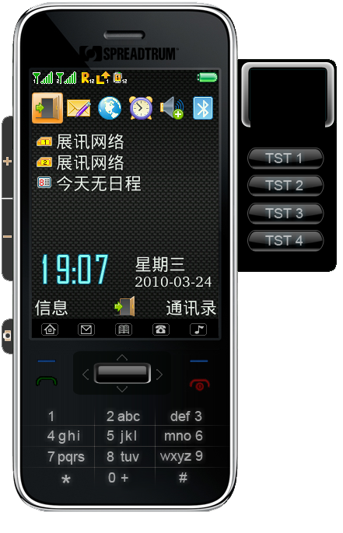

Click the right button on the simulator will show the menu Figure 2-2
              - Simulator menu
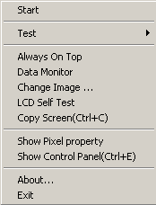

                - Labeled elements on the control panel
Label | Description
Start | Power on the mobile simulator, accelerator key (ctrl+s)
Test | Test items, its sub items can be configured in INI file.
Always On Top | Always on top among all opened windows.
Data Monitor | Data Monitor for messages.
Change Image… | Change the simulator face.
LCD Self Test | LCD self test
Copy Screen(Ctrl+C) | Copy the screen to clipboard.
Show Pixel property | Show LCD Pixel RGB and position.
Show Control Panel(Ctrl+E) | Show control panel dialog.
About… | Show simulator version information
Exit | Exit the simulator, accelerator key (ctrl+q)

Notes for Use Control Panel

Control Panel
Figure 3-1 shows the interface of the simulator control panel.
              - Control Panel
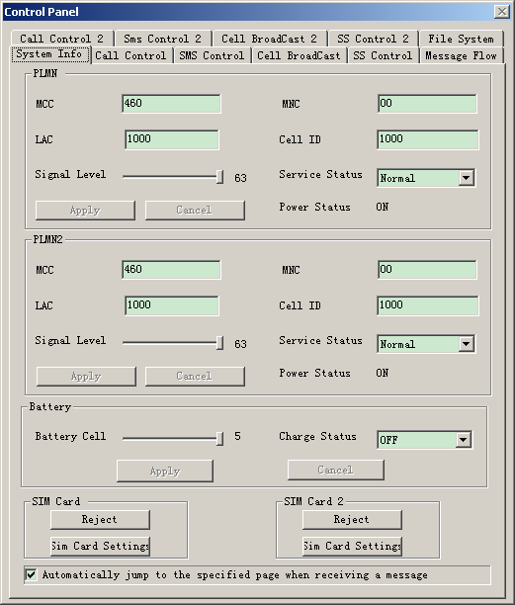

Table 3-1 explains the labeled elements in Figure 3-1.
                - Labeled elements on the control panel
Label | Description
System Info tab | System information
Call Control (2) tab | Initiating and receiving calls for sim(2)
SMS Control (2) tab | Sending and receiving short messages for SIM(2)
Cell Broadcast (2) tab | Cell broadcast for SIM(2)
SS Control (2) tab | Setting supplementary services for SIM(2)
Message Flow tab | Displaying the message exchange between the MMI and the PS
File System tab | This tab will hide until start simulator. U-Disk and SD card file system.

System Information
Figure 3-1 shows the System Info tab page.
              - System Info tab page

Glossary
Acronym | Full Spelling
PLMN | Public Lands Mobile Network; PLMN(2) for SIM(2)
MCC | Mobile Country Code
MNC | Mobile Network Code

Element Description
Table 3-1 describes the labeled elements on the System Info tab page.
                - Labeled elements on the System Info tab page
Label | Description
PLMN(2)-MCC | MCC
PLMN(2)-MNC | MNC
PLMN(2)-LAC | LAC
PLMN(2)-Cell ID | Cell ID
PLMN(2)-Signal level | Signal level of the mobile. The value ranges from 0 to 63.
PLMN(2)-Signal level | Service status of the mobile. The value can be no cell, limited, or normal.
PLMN(2)-Power status | On-off state of the mobile. The value can be ON or OFF.
PLMN(2)-Apply | Application button. To change the value for any of options 1–6, click this button.
PLMN(2)-Cancel | Cancel button. To cancel the change of the value for any of option 1–6, click this button.
Battery-Battery Cell | Battery power level of the mobile. The value ranges from 1 to 63.
Battery-Charge status | Battery charge state of the mobile. The value can be ON or OFF.
Battery-Apply | Application button. To change the value for either of option 10–11, click this button.
Battery-Cancel | Cancel button. To cancel the change of the value for either of options10 and 11, click this button.
SIM Card(2)-Reject | Button for removing or inserting the SIM card.
SIM Card(2)-Sim Card Setting | Button for SIM card information setting.
Check box “Automatically…” | When a message is received on a certain tab from a mobile,  - If this option is selected, the tab page is displayed.  - If this option is cleared, the current tab page is displayed.

How to Use

Setting PLMN
          - Set the values for options 1–6.
          - To validate the settings, click button 8. To cancel the settings, click button 9.

Setting Battery Cell
          - Set the values for options 10 and 11.
          - To validate the settings, click button 12. To cancel the settings, click button 13.

Inserting and Removing the SIM Card
- If option 9 is displayed as Insert, click button 14 and insert the SIM card.
- If option 9 is displayed as Reject, click button 14 and remove the SIM card.

Setting SIM Card Information
Click button 15. Then a dialog box shown in Figure 3-1 is displayed. In the dialog box, set the SIM card information as required. For details about the settings, refer to relevant documents.
              - Setting SIM card information
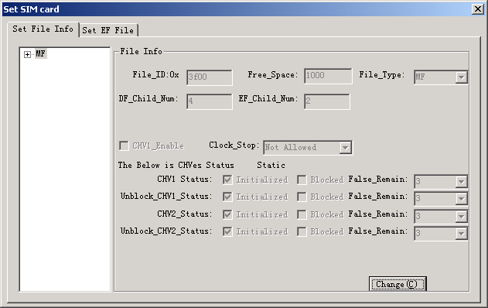

Prohibiting Automatic Tab Jump
To prohibit automatic jump between tabs, clear option 15.

Initiating and Receiving Calls
Figure 3-1 shows the Call Control tab page.
              - Call Control tab page
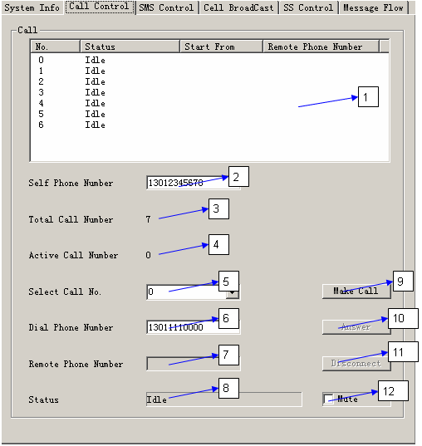

Element Description
Table 3-1 describes the labeled elements on the Call Control tab page.
                - Labeled elements on the Call Control tab page
Label | Description
1 | Status of each line
2 | The phone number that is displayed on the mobile when the control panel calls a mobile.
3 | Total number of lines. Currently, the number is 7.
4 | Total number of currently active lines. "Active" means a non-idle state.
5 | The number of the currently selected line. The minimum value is 0. Options 6–11 show the information about this line.
6 | The number of the mobile that the control panel calls
7 | Remote phone number, namely the following:.  - The number of the mobile that the control panel calls  - The number that the mobile dials when it calls the control panel
8 | Line status.  Idle: The line is idle.  Being Called: The line is being called.  Calling: The line is initiating a call.  Communicating. in conversation state
9 | To initiate a call on the current line.  Note: If Service Status is not Normal, no call can be initiated.
10 | To start a conversation
11 | To reject an incoming call, stop calling, or end a conversation
12 | Mute. If this option is cleared, there is prompt tone if the control panel is called.

How to Use

Initiating a Call from the Control Panel
          - Select in option 5 the number of the line where the call is to be initiated, or select the line in option 1. Ensure that the selected line is in Idle state.
          - Enter in option 6 the phone number to be dialed.
          - Click button 9.
- If the mobile is off, or Service Status on System Info tab is not Normal, the call cannot be initiated.
- If the number of the current line is not the minimum among the available lines, a dialog box is displayed. Select Yes, the call will be initiated from the line of the minimum number. Select No, the call is abandoned.
          - After calling, wait for the response from the callee. Then the line enters Calling state. At this time, you can click option 11 to abandon this call.
          - If the callee receives the call, the line enters the Communicating state. If the callee rejects the call, the line enters the Idle state.

Receiving a Call from Control Panel
- When the MSSim calls the control panel, if the called line is not the currently displayed line, the called line is automatically displayed on the tab. In addition, the incoming call is shown by animation. If option 12 is cleared, there is also prompt tone.
- To accept the call, click button 10, and then the line enters the Communicating state. To reject the call, click button 11, and then the line enters the Idle state.

Terminating a Call During Conversation
When the line is in Communicating state, to terminate the call and to make the line enter Idle state, click button 11. You can also terminate it from the MSSim and then the line enters Idle state as well.

Sending and Receiving a Short Message
Figure 3-1 shows the SMS Control tab page.
              - SMS Control tab page
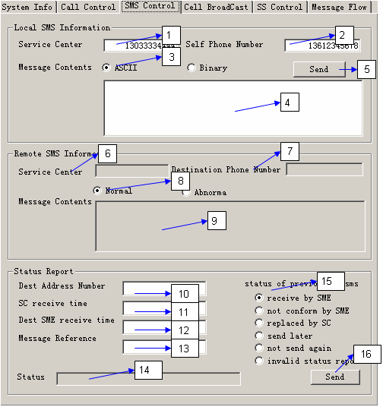

Element Description
Table 3-1 describes the labeled elements on the SMS Control tab page.
                - Labeled elements on the SMS Control tab page
Label | Description
1 | Number of the service center
2 | The number of the sender when the control panel sends a message to a mobile
3 | Format in which the message is sent, ASCII or binary
4 | Content of the message
5 | To send the message
6 | The number of the service center from which the message is received
7 | The number of the sender when a mobile sends a message to the control panel
8 | Status of the receiver
9 | Content of the received message
10 | Mobile number of the receiver (destination address)
11 | Time when the service receives the message
12 | Time when the receiver (destination address) receives the message
13 | Reference of the sent message
14 | Prompt that a message is received or sent
15 | To select a status report
16 | To send a mobile status report

How to Use

Sending Messages from the Control Panel
          - Enter in option 2 the number of the sender and in option 4 the content to be sent.
          - Click button 5 to send the message.
If the mobile is off, or the value for option 6 in 3.2.1 Figure 3-1 is not normal, the message cannot be sent.
          - After the message is sent, there is a prompt tone, and option 14 prompts that a message is sent.

Receiving Messages from the Control Panel
- When the control panel receives a message from the MSSim, if option 16 in 3.2.1 Figure 3-1 is selected, the SMS Control tab is automatically displayed on the control panel.
- Option 6 displays the service center that sends the message, and option 9 displays the message content. Option 14 prompts that a message is received. At the same time, there is a prompt tone.

Cell Broadcast
Figure 3-1 shows the Cell Broadcast tab page.
              - Cell Broadcast tab page
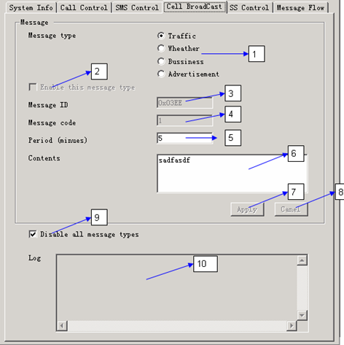

Element Description
Table 3-1 describes the labeled elements on the Cell Broadcast tab page.
                - Labeled elements on the Cell Broadcast tab page
Label | Description
1 | Message type currently selected. Options 2–8 are all set for the messages of this type.  - Traffic: traffic messages  - Weather: weather messages  - Business: business messages  - Advertisement: advertisement messages
2 | If this option is selected, the control panel broadcasts the messages of this type at specified intervals.  If this option is cleared, the messages if this type cannot be broadcasted.  Note: If option 9 is selected, this option is automatically cleared.
3 | Message ID. Messages of different types correspond to different Message IDs. When broadcasting, the ID is broadcasted to the mobile at the same time.
4 | Message code.  For the messages of a certain type, this code is plus 1 and sent to the mobile as soon as a new message is broadcasted.
5 | Period for broadcasting the messages of this type, in units of minute.
6 | Content of the broadcasted message.
7 | Application button. After the values for options 5 and 6 are set, to validate the settings, click this button.  Note: If option 2 is cleared, the system automatically clicks this button and sent the message at once.
8 | Cancel button. After the values for options 5 and 6 are set, to cancel the settings, click this button.
9 | If this option is selected, messages of all types are never broadcasted. That is, all types of messages are prohibited. Option 2 is automatically cleared.
10 | This option records the information each time a message is broadcasted.

How to Use

Setting to Send Broadcast Messages of a Type
          - In option 1, set the type of the message to be sent.
          - In option 5, set the period for sending the message.
          - In option 6, set the content to be sent.
          - Click button 7 to make the settings take effect. Or click button 8 to cancel the settings.
Note
After you click option 7, if option 2 is cleared, the system automatically selects it. If the mobile is on, the message is sent at once.

Prohibiting Broadcast Messages of a Type
          - In option 1, set the type of the message.
          - If option 2 is cleared, the messages of this type have been prohibited. If option 2 is selected, clear it.

Validating Broadcast Messages of a Type
          - In option 1, set the type of the messages.
          - If option 2 is selected, the messages of this type have been validated. If option 2 is cleared,
          - If option 9 is selected, clear option 9. If option 9 is cleared, select option 2.

Prohibiting Broadcast Messages of All Types
Select option 9. Then no broadcast messages of all types will be sent.

Setting Supplementary Services
Figure 3-1 shows the SS Control tab page.
              - SS Control tab page
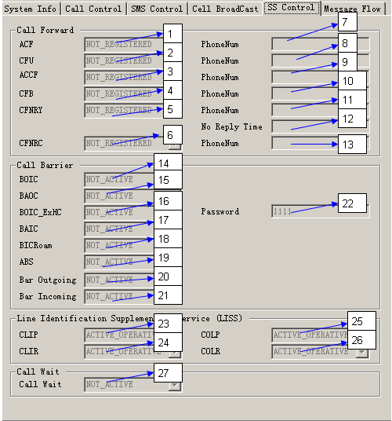

Glossary
Term | Description
Call Forward | Call forward
Call Bar | Call bar
Call Wait | Call wait
SS | Supplementary Service
LISS | Line Identification Supplementary Service
ACF | All Call Forwarding SS
CFU | Call Forwarding Unconditional
ACCF | All Conditional Forwarding SS
CFB | Call Forwarding on mobile subscriber Busy
CFNRY | Call Forwarding on No Reply
CFNRC | Call Forwarding on mobile subscriber Not Reachable
BOIC | Barring of Outgoing International Calls
BAOC | Barring of All Outgoing Calls
BOIC_ExHC | Barring of Outgoing International Calls Except those directed to the Home PLMN
BAIC | Barring of All Incoming Calls
BICRoam | Barring of Incoming Calls when Roaming outside home PLMN Country
ABS | All Barring Service
CLIP | Calling Line Identification Presentation
CLIR | Calling Line Identification Restriction
COLP | COnnected Line identification Presentation
COLR | COnnected Line identification Restriction

                - Status of supplementary services
Supplementary Service | Service Status
Call Forward | NOT_PROVITION  NOT_REGISTERED  NOT_ACTIVE  ACTIVE_OPERATIVE  ACITVE_QUIESCENT
Call Bar | NOT_PROVITION  NOT_ACTIVE  ACTIVE_OPERATIVE  ACITVE_QUIESCENT
LISS | NOT_PROVITION  ACTIVE_OPERATIVE  ACITVE_QUIESCENT
Call Wait | NOT_PROVITION  NOT_ACTIVE  ACTIVE_OPERATIVE  ACITVE_QUIESCENT

Element Description
Table 3-1 describes the labeled elements on the SS Control tab page.
                - Labeled elements on the SS Control tab page
Label | Description
1 | Current service status of ACF
2 | Current service status of CFU
3 | Current service status of ACCF
4 | Current service status of CFB
5 | Current service status of CFNRY
6 | Current service status of CFNRC
7 | Phone number of ACF
8 | Phone number of CFU
9 | Phone number of ACCF
10 | Phone number of CFB
11 | Phone number of CFNRY
12 | No reply time of CFNRY (in units of second)
13 | Phone number of CFNRC
14 | Current service status of BOIC
15 | Current service status of BAOC
16 | Current service status of BOIC_ExHC
17 | Current service status of BAIC
18 | Current service status of BICRoam
19 | Current service status of ABS
20 | Current service status of Bar Outgoing
21 | Current service status of Bar Incoming
22 | Password of BOIC_ExHC
23 | Current service status of CLIP
24 | Current service status of CLIR
25 | Current service status of COLP
26 | Current service status of COLR
27 | Current service status of Call Wait

How to Use
You can set or query the service status or other information about Call Forward, Call Bar, LISS, and Call wait, through the MSSim.

Displaying the Message Exchange Between the MMI and the PS
Figure 3-1 shows the Message Flow tab page.
              - Message Flow tab page
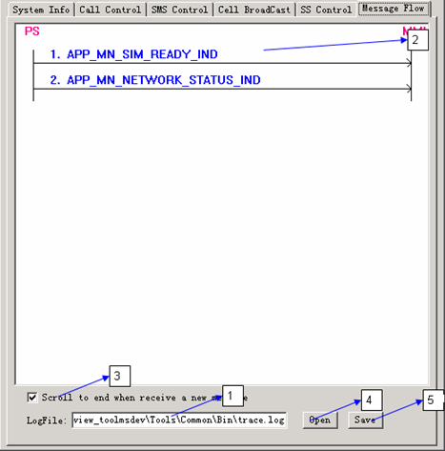

Element Description
Table 3-1 describes the labeled elements on the Message Flow tab page.
                - Labeled elements on the SMS Control tab page
Label | Description
1 | The currently used file that stores the messages exchanged between PS and MMI in form of text.  Note: This option is set to trace.log by default. This file is cleared each time the mobile is switched on.
2 | The currently used file that stores the messages exchanged between the PS and MMI in form of picture.
3 | If this option is selected, window 2 scrolls to the end in the case of a new message.
4 | Click this button to choose another file as the current file.
5 | Click this button to save the current file as another file.

How to Use

Choosing a File to Display the Message Exchange
          - Click button 4. A dialog box is displayed for you to open the required file.
          - The message exchange between the MMI and PS is displayed in window 2.

Saving the Current File
Click button 4. A file saving dialog box is displayed. You only need to enter the file name.

Observing the Message Exchange in Real Time
          - Clear option 16 in 3.2.1 Figure 3-1.
          - Select the Message Flow tab.
          - Select option 3.
          - In this case, new messages of the selected file are displayed in window 2 in real time.

Using the Analog File System
The analog file system uses image files to simulate memory devices, namely, UDisk and SDCard, and provides unified interfaces for the upper layer.
Figure 3-1 shows the File System tab page.
              - File System tab page
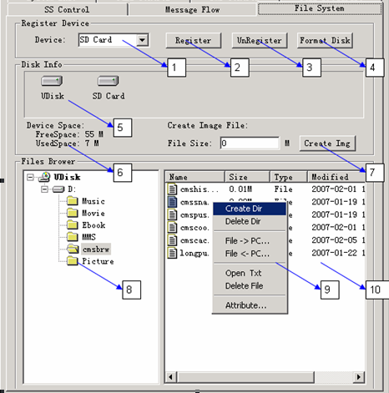

Glossary
Acronym | Meaning
SFS | Super file system. It is a new interface of FAT.
FFS | File System with FAT and EFS. It is an interface of FAT and EFS.
FAT | FAT file system. It is the origin interface of file system.

Element Description
Table 3-1 describes the labeled elements on the File System tab page.
                - Labeled elements on the File System tab page
Label | Description
1 | Shows the device supported by the analog file system (currently, UDisk and SDCard are supported).
2 | Registers a device (which must have been formatted).
3 | Unregisters a device.
4 | Formats a disk (actually formats image files).
5 | Lists the devices that have been registered.
6 | Shows the current usage of the disk.
7 | Creates image files to simulate devices.
8 | Shows the directory structure of the current disk.
9 | Functional menu of the analog file system.
10 | File browser.

How to Use

Registering a Disk
          - Find the image file under the Disk directory, and ensure that the file is read/write.
          - Select the disk you need to register in option 1.
If the disk is new, format it first (by clicking Format Disk).
          - Click Register.
If the disk is registered successfully, the disk is displayed in option 5.

Creating a Disk
          - In text box 7, enter the disk size.
          - Click Create Img.
          - Enter the file name (UDisk/SDCard).
          - Copy the image file that has been created to the Disk directory.
Before registering a new disk, format it first.

Browsing Files and Directories on the Disk
Select the registered disk in option 5.
The disk usage is displayed in option 6.The directory structure of the disk is displayed in option 8. The information of the files under the current directory is displayed in option 10.

Operating Files and Directories on the Disk
          - Right-click in area 10, the functional menu 9 pops up.
- Create Dir: to create a folder
- Delete Dir: to delete a folder
- File -> PC: to export the files in the analog file system to the PC file system
- File <- PC: to export the files in the PC file system to the analog file system
- Open Txt: to open a file in text form
- Delete File: to delete a file
- Attribute…: to show the attributes of a folder or file

File Import/Export Between Analog File System and Window File System
To export files, do as follows:
          - Select the file you need to export in option 10.
          - Right-click option 10 and the functional menu 9 pops up.
          - Choose File -> PC….
          - Select the path to export the file.
To import files, do as follows:
          - Right-click option 10 and then the functional menu 9 pops up.
          - Choose File <- PC….
          - Select the file you need to import. The file size must be less than the remaining size on the disk.

Notes for Development
ConPan.dll encapsulates the following functions:
- Starting the control panel
- Ending the control panel
- Interaction between the control panel and the MSDev

Required Files for Development
Table 4-1 lists the required files.
                - Files required for development
File Type | File Name | Description
Header File | ConPan.h | States the function for starting and ending the control panel.
Header File | ConPanFunc.h | States the functions that are called back by ConPan.dll.
Implementation file | ConPan.cpp | Defines the functions stated in ConPan.h and ConPanFunc.h.
Static library file | ControlPanel2.lib | Static library file, containing the functions stated in ConPan.h.
Dynamic library file | ControlPanel2.dll | Dynamic library file, containing the functions stated in ConPan.h.
Dynamic library file | SIMConPad.dll | Dynamic link library, containing the function of setting the SIM card.

The dependent header files and the dependencies are as follows:
ConPan.h: sci_api.h, sci_types.h
ConPanFunc.h: sci_api.h, sci_types.h, tasks_id.h

APIs

Functions Declared in ConPanFunc.h
All the functions declared in ConPanFunc.h are defined in ConPan.cpp. You need to call the RTOS context to save and restore these functions. Therefore, you need to change the function according to the specified RTOS.

InnerSCICreateSignal
[Prototype]
void InnerSCICreateSignal (
xSignalHeader* ppSig,
uint16 nSigCode,
uint16 nSigSize,
BLOCK_ID nSender
);
[Description]
To create signals
[Parameters]
Parameter | Description
ppSig | Pointer to another pointer. A value is assigned after the function returns. It points to the address of the created signal.
nSigCode | Code of the signal to be created
nSigSize | Size of the signal to be created
nSender | Sender of the signal

[Return Value]
None.
[Note]
Because SCICreateSignal cannot be directly called in ConPan.dll, ConPan.dll calls this function to create signals.

InnerSCIFreeSignal
[Prototype]
void InnerSCIFreeSignal (
xSignalHeader pSig
);
[Description]
To release signals
[Parameters]
pSig: a pointer to the signals to be released
[Return Value]
None.
[Note]
Because SCIFreeSignal cannot be directly called in ConPan.dll, ConPan.dll calls this function to release signals.

InnerSCISendSignal
[Prototype]
void InnerSCISendSignal (
xSignalHeader pSig,
BLOCK_ID nReceiver
);
[Description]
To send signals
[Parameters]
Parameter | Description
pSig | Pointer to the signal to be sent
nReceiver | Receiver of the signal

[Return Value]
None.
[Note]
Because SCISendSignal cannot be directly called in ConPan.dll, ConPan.dll calls this function to send signals.

SendCPMsgToPS
[Prototype]
int SendCPMsgToPS (
xSignalHeader pSig
);
[Description]
To send signals to the PS of the main program
[Parameters]
Parameter | Description
pSig | Pointer to the signal to be sent

[Return Value]
None.
[Note]
ConPan.dll calls this function to send signals to the PS of the main program.

SendCPMsgToConPan
[Prototype]
int SendCPMsgToConPan (
xSignalHeader pSig
);
[Description]
To send messages to the control panel
[Parameters]
Parameter | Description
pSig | Pointer to the signal to be sent

[Return Value]
None.
[Note]
When a message is sent from the PS of the MSDev to the control panel, call this function.

InnerPSRegisterMsgHandler
[Prototype]
void InnerPSRegisterMsgHandler (void);
[Description]
To set the callback function for the PS of the MSDev so that messages can be sent from the PS to the control panel.
[Parameters]
None.
[Return Value]
None.
[Note]
When a message is sent from the PS of the MSDev to the control panel, call this callback function.

InnerThreadContextSave
[Prototype]
void InnerThreadContextSave (void);
[Description]
To save the context of the current RTOS
[Parameters]
None.
[Return Value]
None.
[Note]
Because ConPan.dll must use the RTOS functions of the main program, this function is used to reserve the context.

InnerThreadContextRestore
[Prototype]
void InnerThreadContextRestore (void);
[Description]
To restore the RTOS context
[Parameters]
None.
[Return Value]
None.
[Note]
Because ConPan.dll must use the RTOS functions of the main program, this function is used to restore the context.

InnerInsertSIM/InnerRejectSIM/InnerShowPadSIM/InnerQuerySIM
[Prototype]
void InnerInsertSIM (void);
void InnerRejectSIM (void);
void InnerShowPadSIM (void);
BOOL InnerQuerySIM (void);
[Description]
To control the SIM card
[Parameters]
None.
[Return Value]
None.
[Note]
Because SIMCP_XXX cannot be directly called in ConPan.dll, ConPan.dll calls this function to control the SIM card.

Functions Stated in ConPan.h

CP_StartControlPanel
[Prototype]
BOOL CP_StartControlPanel (
int nX = -1,
int nY = -1
);
[Description]
To start the control panel, in a synchronous (blocking) manner
[Parameters]
Parameter | Description
nX | The location (pixel) of the left boundary of the control panel on the screen. If nX < 0 or nX ≥ screen width, the left boundary is at the screen center.
nY | The location (pixel) of the upper boundary of the control panel on the screen. If nY < 0 or nY ≥ screen height, the upper boundary is at the screen center.

[Return Value]
TRUE: success
FALSE: failure
[Note]
Because the control panel needs to call the RTOS callback functions, start the RTOS before calling this function.

CP_EndControlPanel
[Prototype]
void CP_EndControlPanel (void);
[Description]
To end the control panel.
Because this function is in a synchronous manner, the control panel is bound to have been released after the function returns.
[Parameters]
None.
[Return Value]
None.
[Note]
Because the control panel needs to call the RTOS callback functions, call this function before ending the RTOS.

CP_ RegisterFunctions
[Prototype]
void CP_RegisterFunctions (
CP_EXT_FUNC_LIST* pFuncList
);
[Description]
To be called when the MSSim is started, so as to register external functions for the control panel to call
[Parameters]
Parameter | Description
pFuncList | Pointer to the CP_EXT_FUNC_LIST structure.

[Return Value]
None.
[Note]
None.

Integrating Control Panel Functions into MSDev
To integrate the functions of the control panel into the main program (MSDev), do as follows:
          - Add ConPan.h, ConPanFunc.h, ConPan.cpp into the MSDev project.
          - Ensure that the dependent header files can be contained.
          - Ensure that ConPan.cpp calls the correct RTOS functions.
          - Start the RTOS in the main program.
- Set the function that needs to be called back by the control panel.
- Call CP_StartControlPanel to start the control panel.
- Get the control panel function that is called back by the main program.
          - When exiting the main program, call CP_EndControlPanel first and then stop the RTOS.
          - Build this project to run the main program. Then the functions of the control panel can be used.
Start the control panel as follows:
CP_StartControlPanel(-1, -1);
End the control panel as follows:
CP_EndControlPanel();

